Biology, Castle View High School
Dr. Jason R Mayberry
Study Guide: Intermolecular Bonds
Vocabulary Summary
- Intra-Molecular Bonds
- Inter-Molecular Bonds
- Hydrogen Bonds
- Van Der Waals Forces
- London Forces
Conceptual Questions
- Compare and contrast Intramolecular Bonds and Intermolecular Bonds.

- What are Hydrogen Bonds? What must be true about the parts of the two molecules where they form?
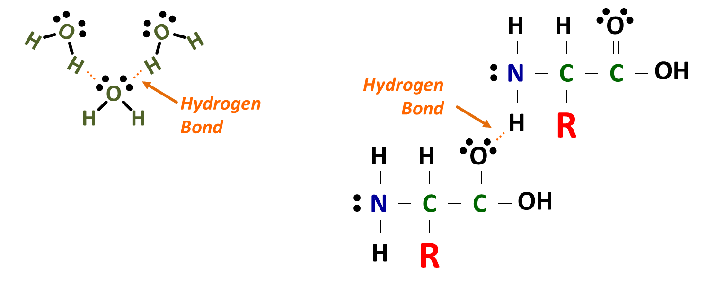

- Describe the role of hydrogen bonds in forming and melting ice?

- What are Van-De Waals Attractions? What must be true about the parts of the two molecules where they form?
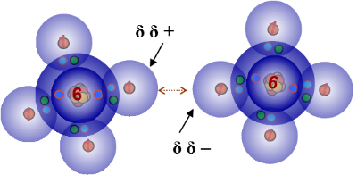

- Where do Hydrogen Bonds and Van Der Waals interactions fit in relation to the bonding continuum of Intra-Molecular Bonds. Why?
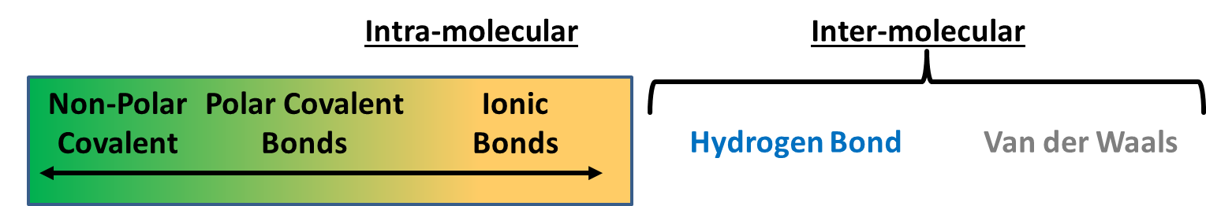

- What is the pattern in terms of bond strength in the diagram below? Explain why this is so.

